File Upload Checks

Access the application and move to the Dashboard

Click on a kanban Card

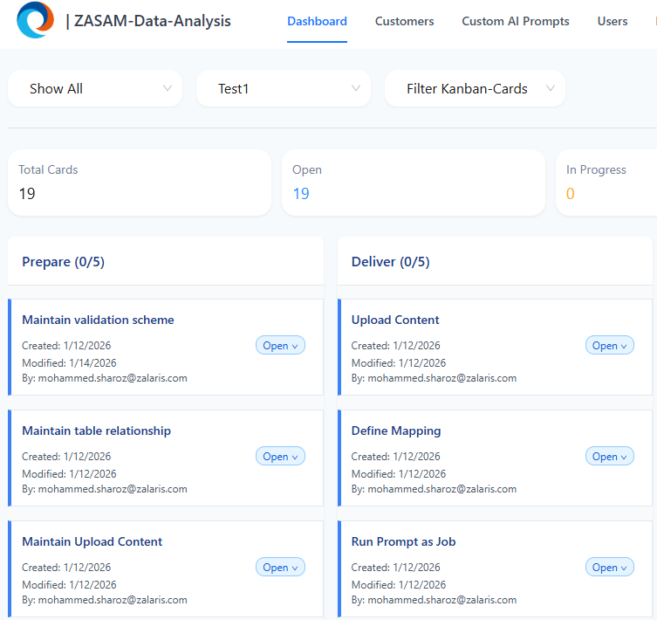

Option to create a Folder is available

Click on Create Folder give the Folder name and capture the request

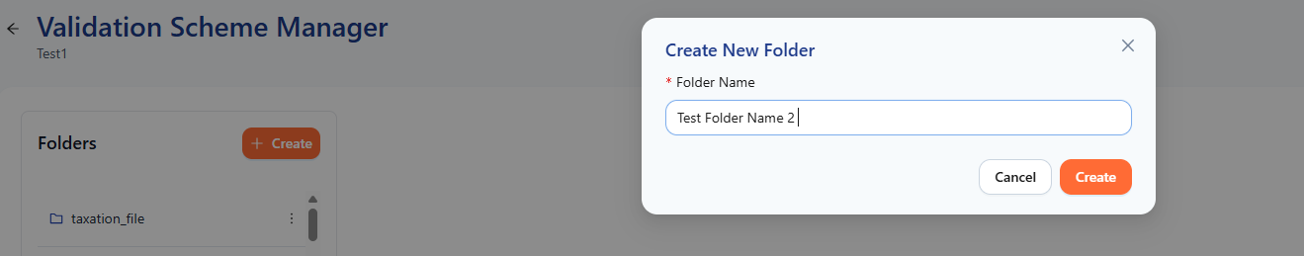

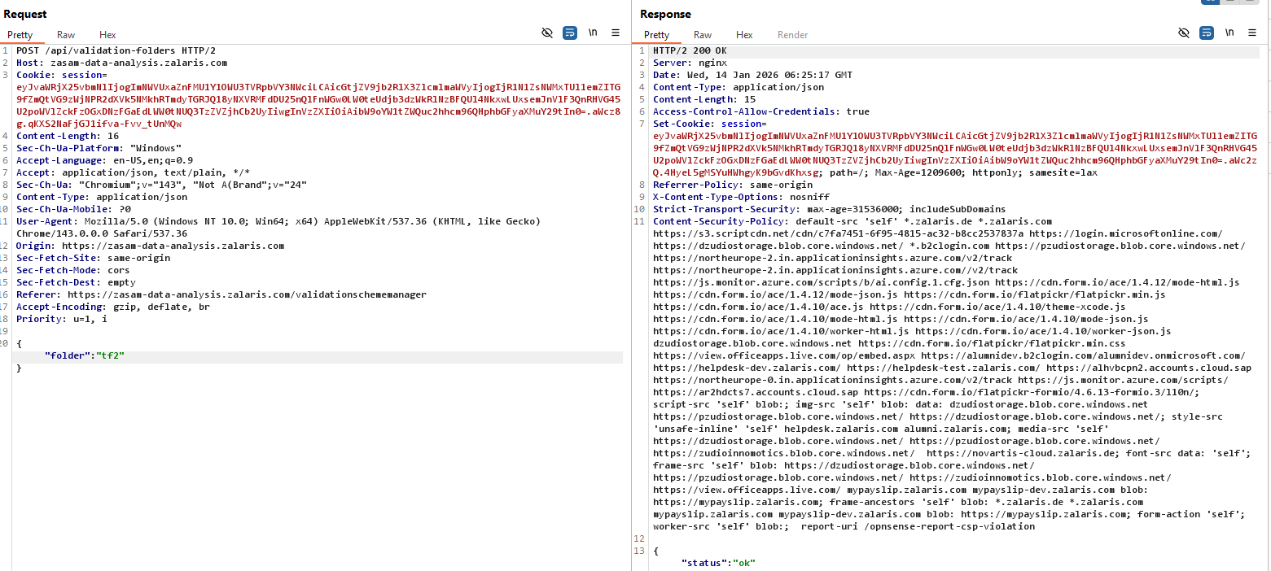

Alter the request parameter by injection LFI payloads to check whether the application accepts or rejects the request

The application accepts the payload and returns response 200 OK

Refer screenshot attached below for evidence

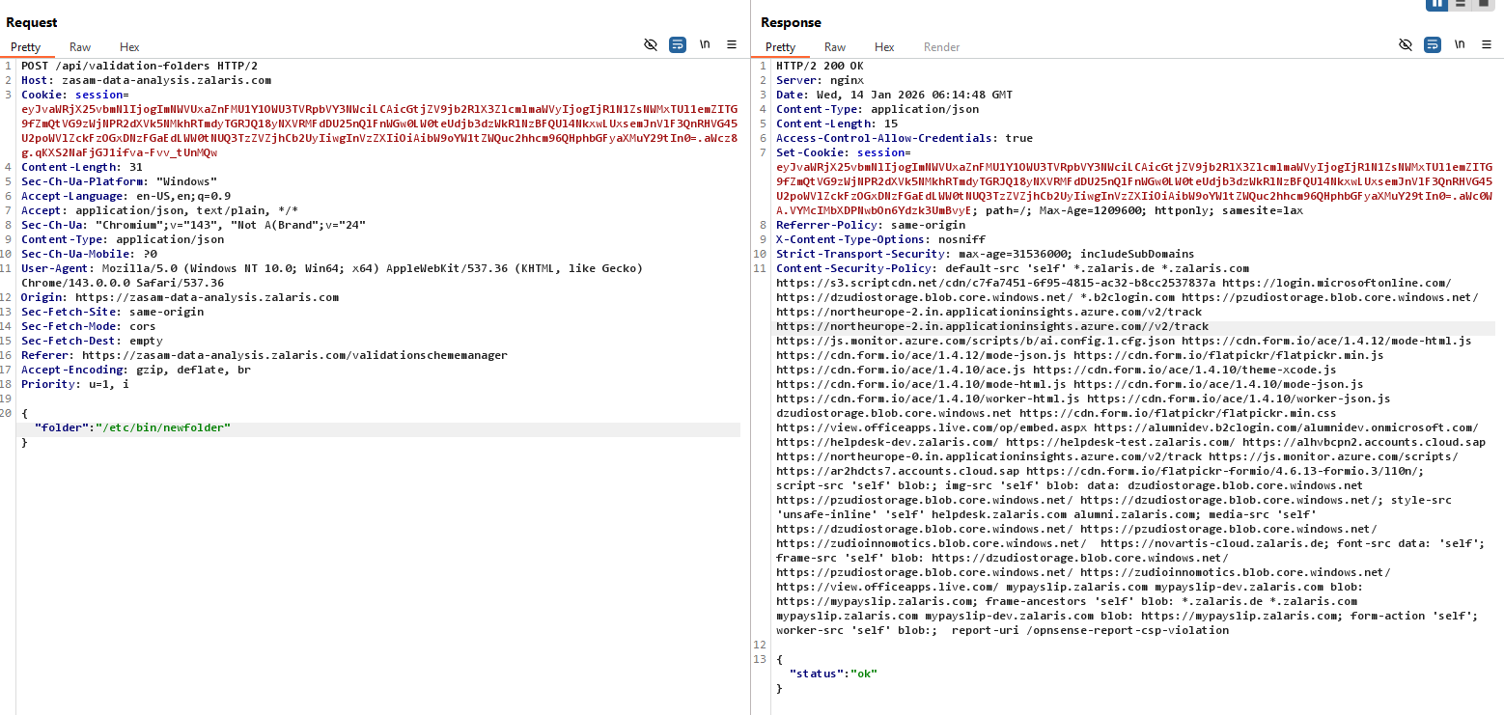

The application accepts files of different format and executes the file and renders them

The file was uploaded to kanbancard and request was captured

The file type was altered to pdf, change the content type to application/pdf

Refer Screenshot attached below for reference

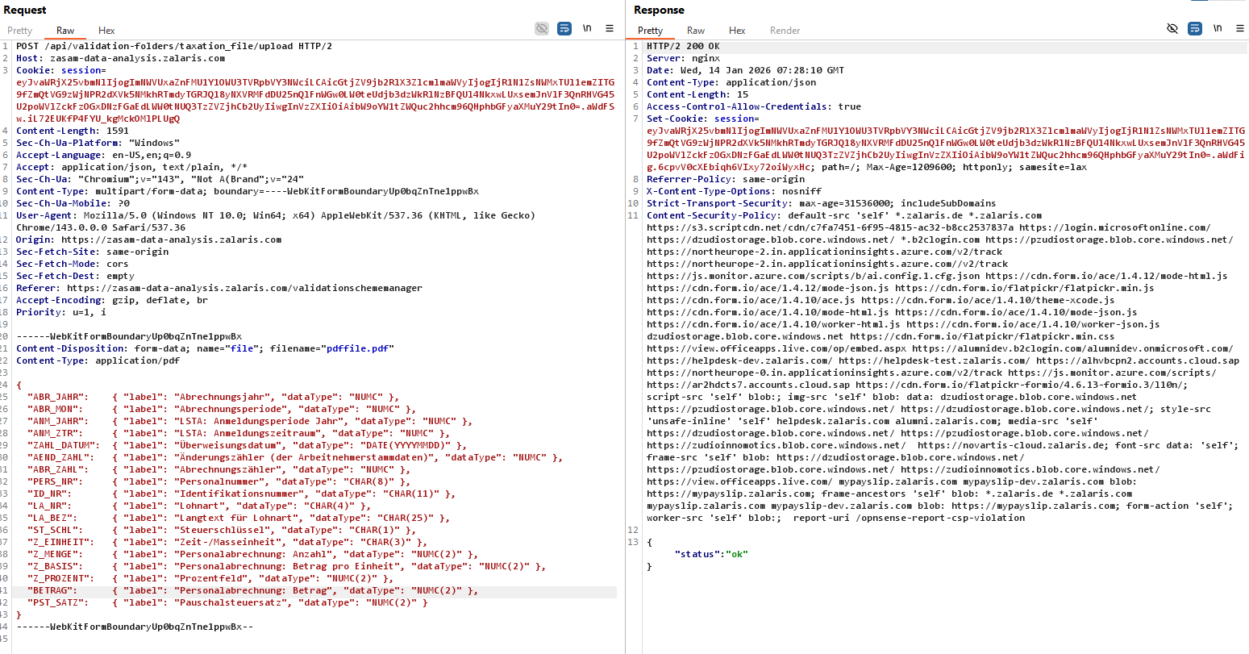

The file is accepted and server responds with 200 OK response

The file is not reflected in the uploaded folder

Refer screenshot attached below for refernce

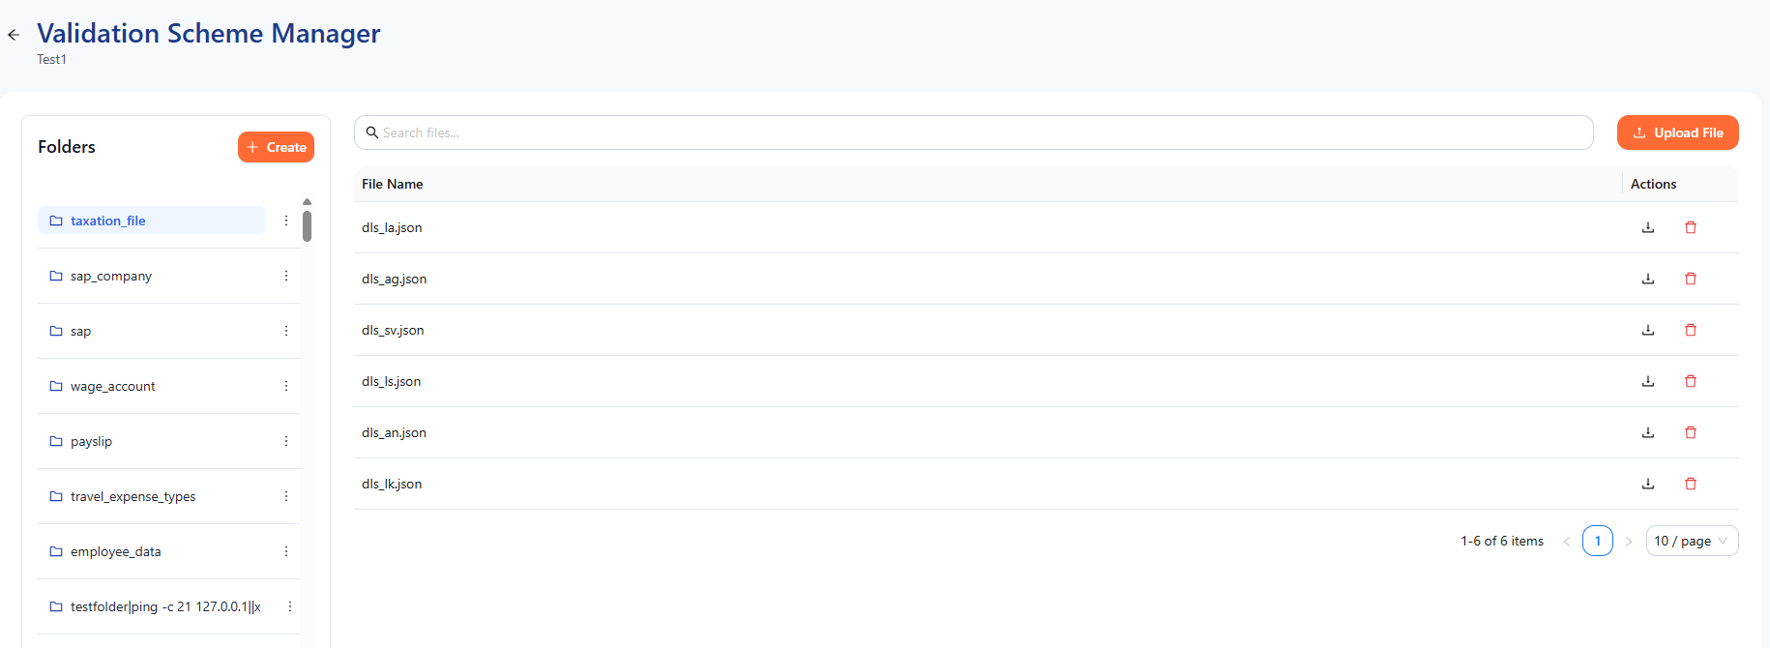

Access the application via the url path - https://zasam-data-analysis.zalaris.com/api/validations/taxation_file/pdffile.pdf

The file is fethced and the serverrenders it as pdf

Refer screenshot atatched below for refernce

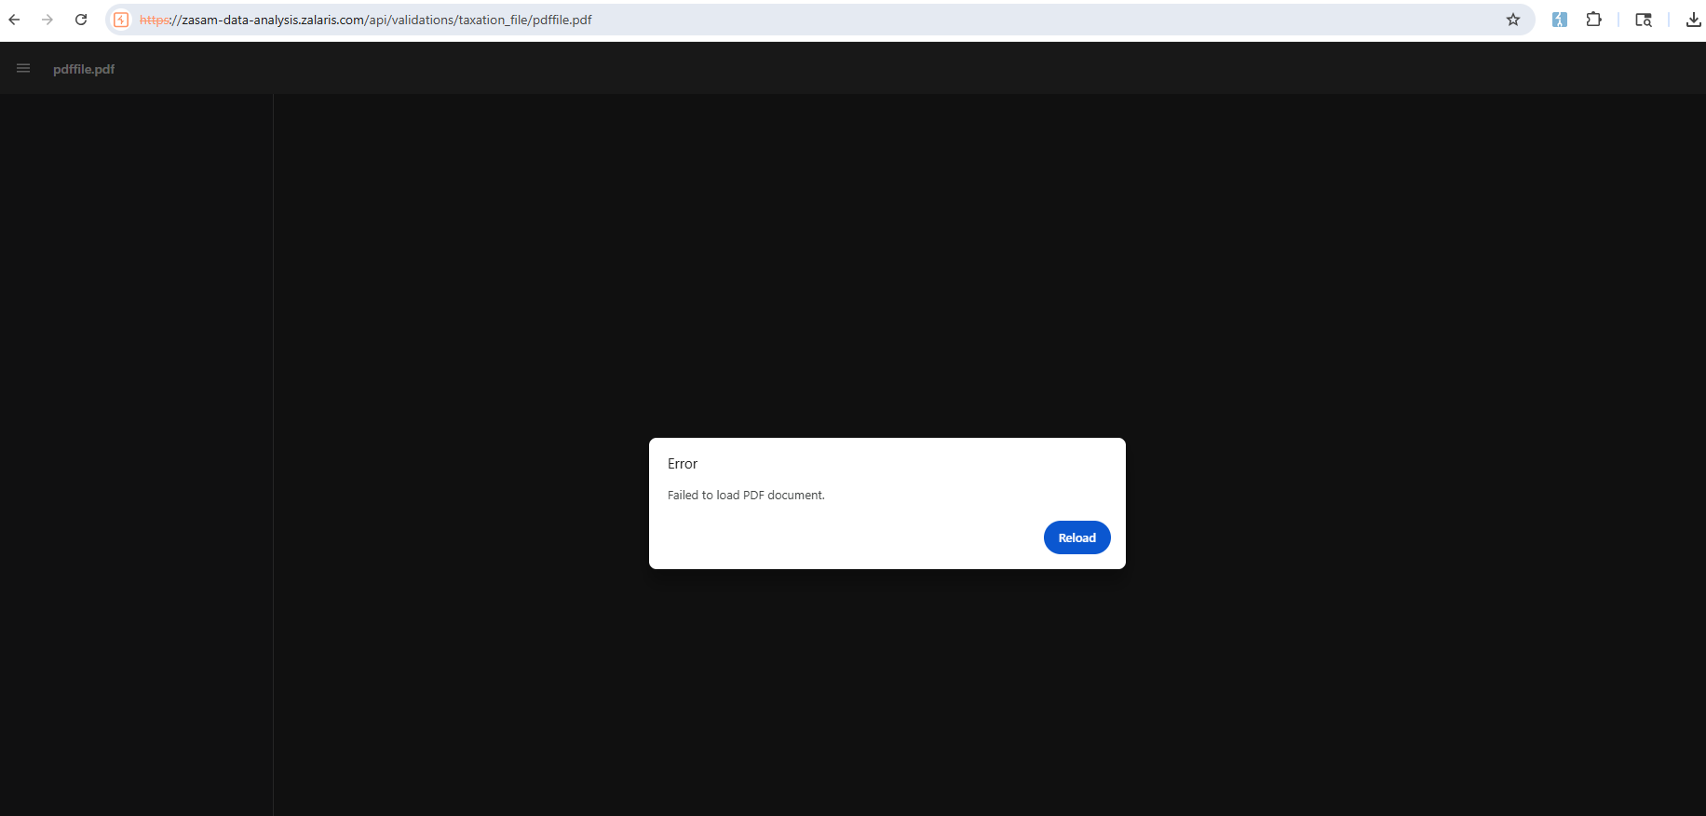

Script Execution Check

Upload a html file with alert script by tapering with the file extension

And the content type

The request is accepted the file is uploaded

Try to re-access the file and check whether the injected script is executed or not

The file is stored and can be accessed but the injeced script is not executed and throws the following error

The error is given below

Executing inline script violates the following Content Security Policy directive 'script-src 'self' blob:'. Either the 'unsafe-inline' keyword, a hash ('sha256-stndfhRksfSjwzayjDsFlwRVluHf+LYXiS/aeVCua4U='), or a nonce ('nonce-...') is required to enable inline execution. The action has been blocked.

Check whether the script execution is allowed using Same Origin Policy

The application CSP detects the inline script execution and blocks it but it allows the script execution via same origin policy

Access the application’s kanbancard and upload a js file with the alert script

Refer screenshot attached below for evidence

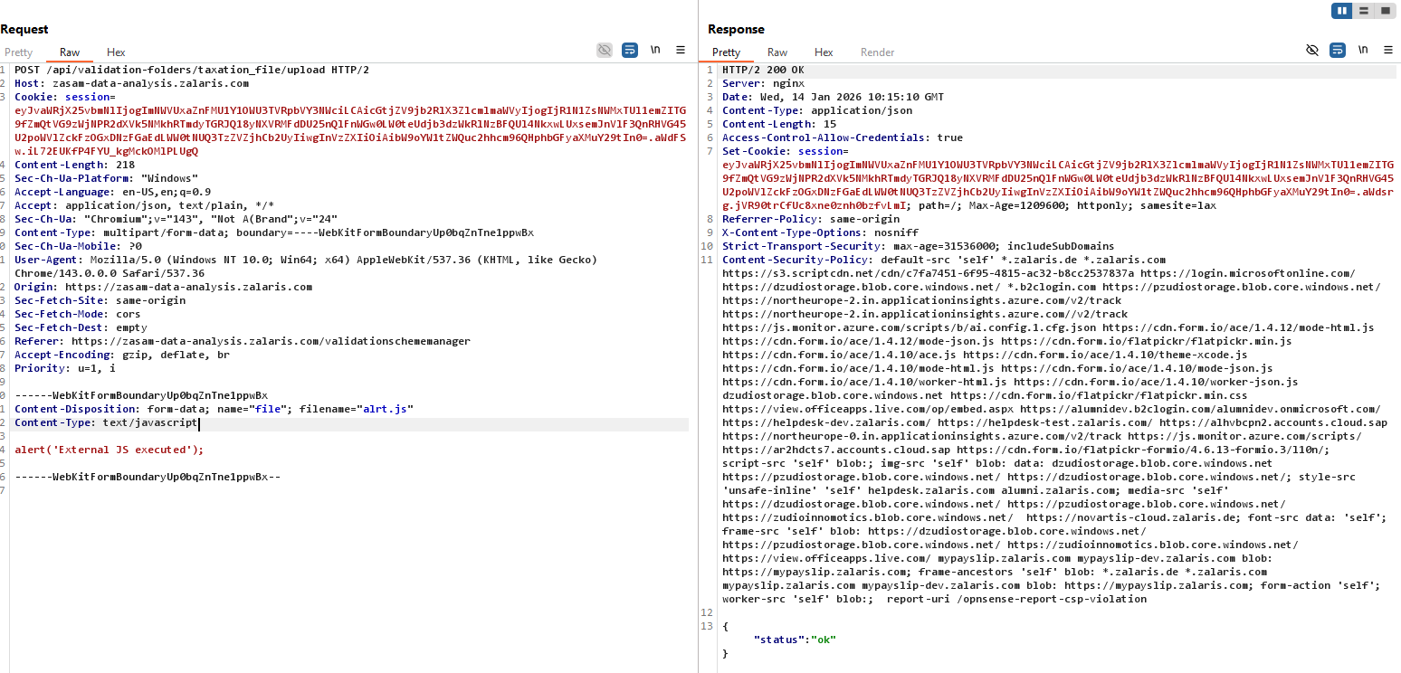

Now create a new html file that calls the js script testfile1.html

Refer screenshot attached below for evidence

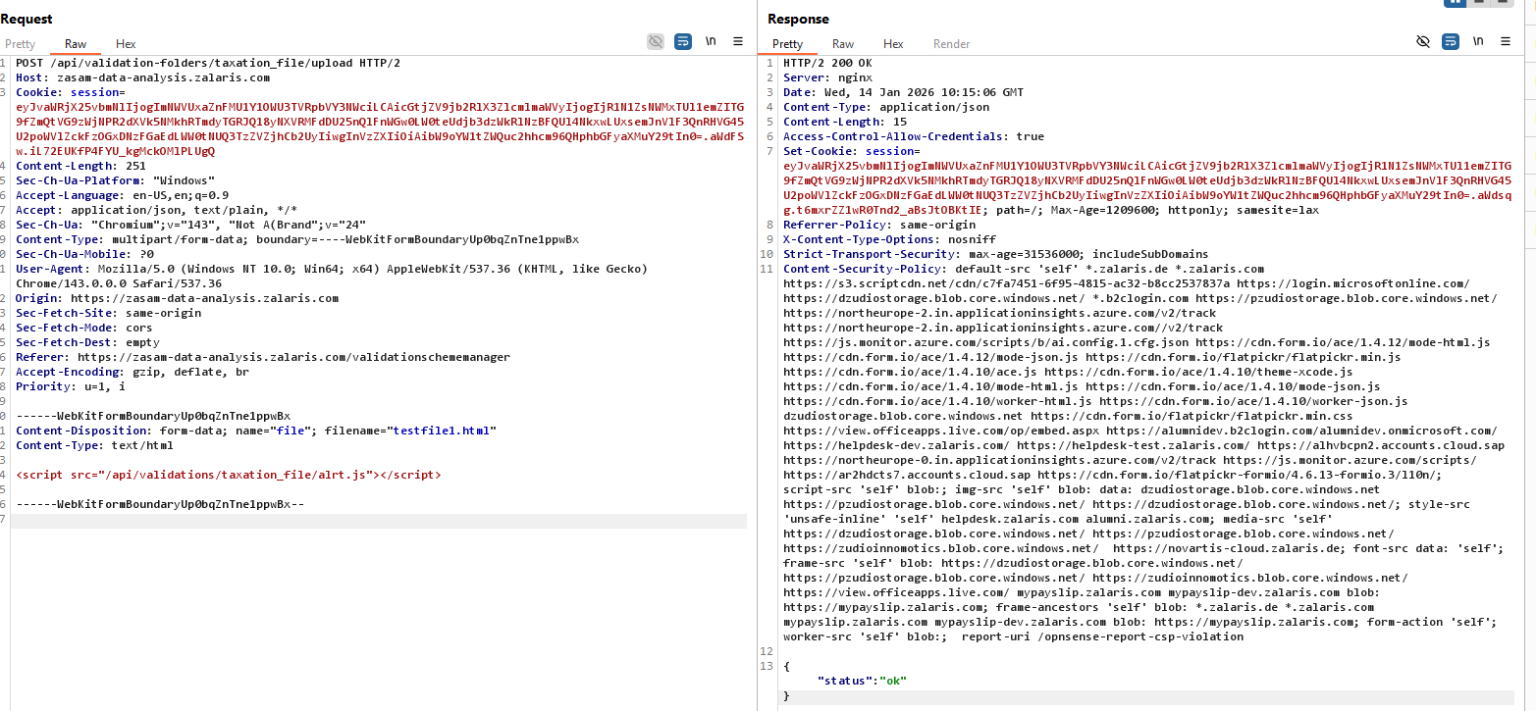

The script is executed and XSS is received in when the file is called

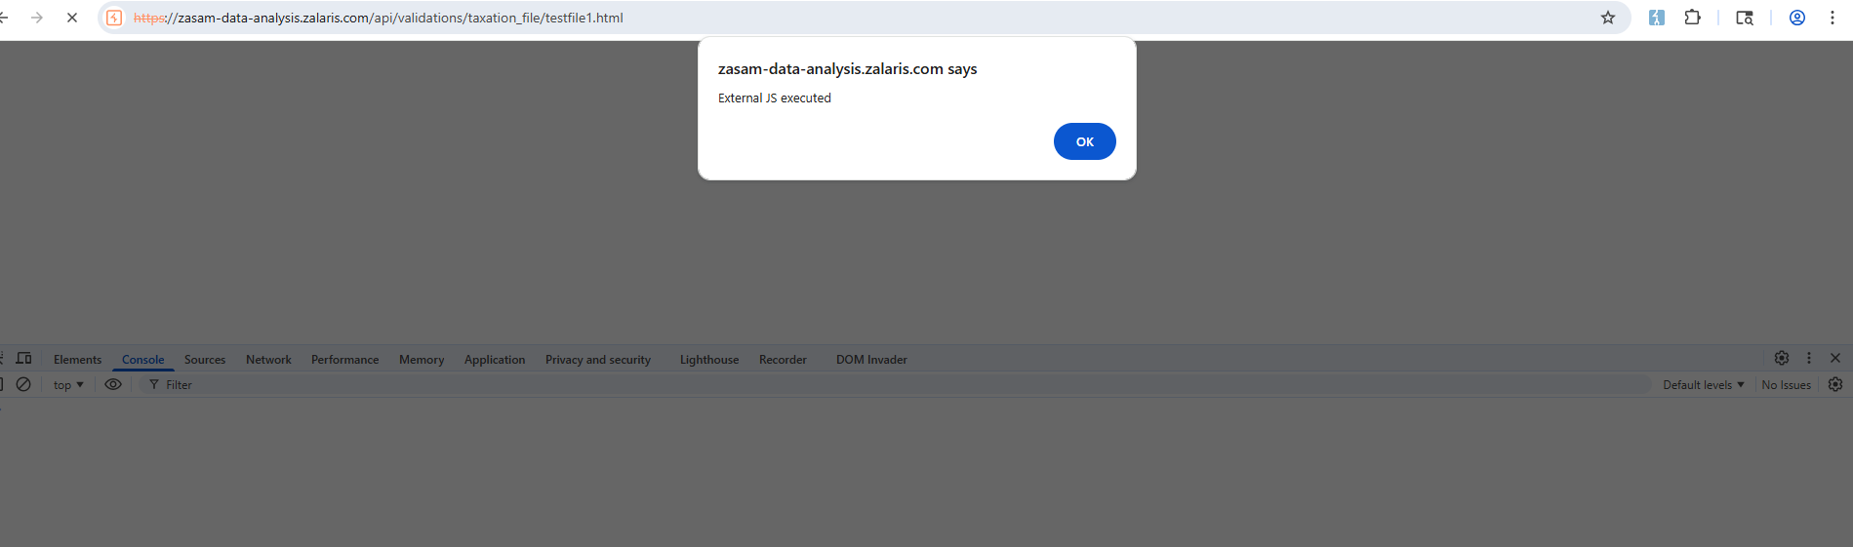

The request accepts - legacy content type header value - text/javascript [test for other legacy content Type headers ]

Check for

-domain.alert:

Alert is received this confirms that the xss is of same origin

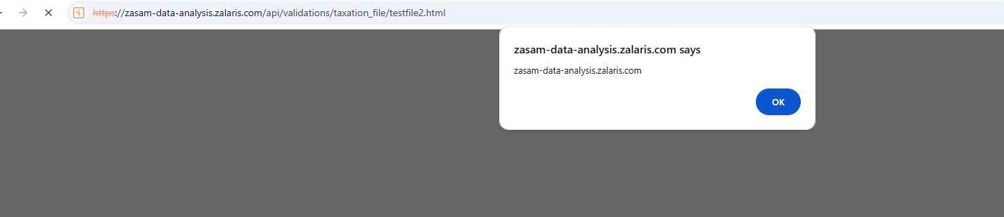

Document.cookie is not executed as the cookie ‘session’ is set to HttpOnly

Refer screensghot attached below for evidence

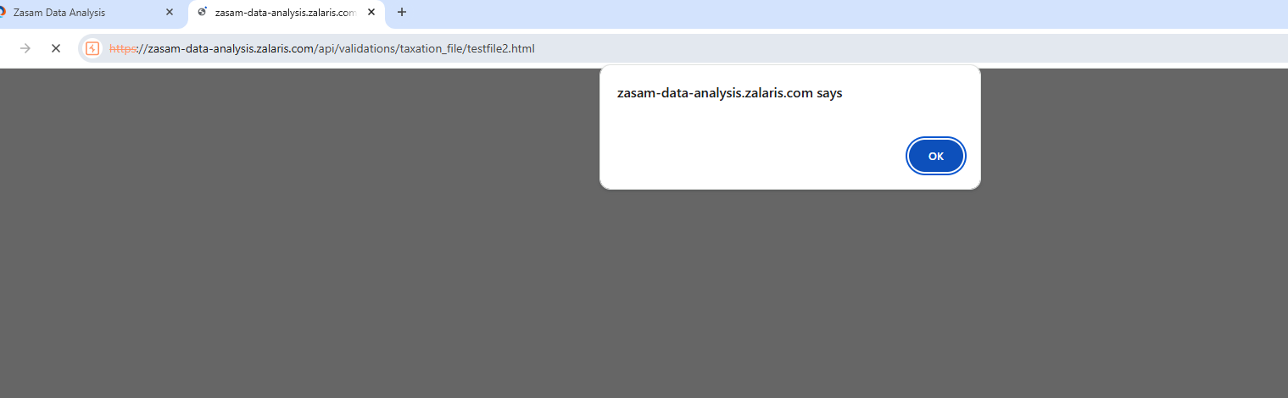

Test For CSRF

The application is tested for CSRF by sending a request to view file

The request was not successful as the cookie is not auto added and the value has been set to Same-site :lax

